Group id : A6

Project Name : Stock Candle

**Assignment 13**

Title: Prepare a State Model

Problem Statement: Identify States and events for your system. Study state transitions and

identify Guard conditions. Draw State chart diagram with advanced UML 2 notations.

Theory :

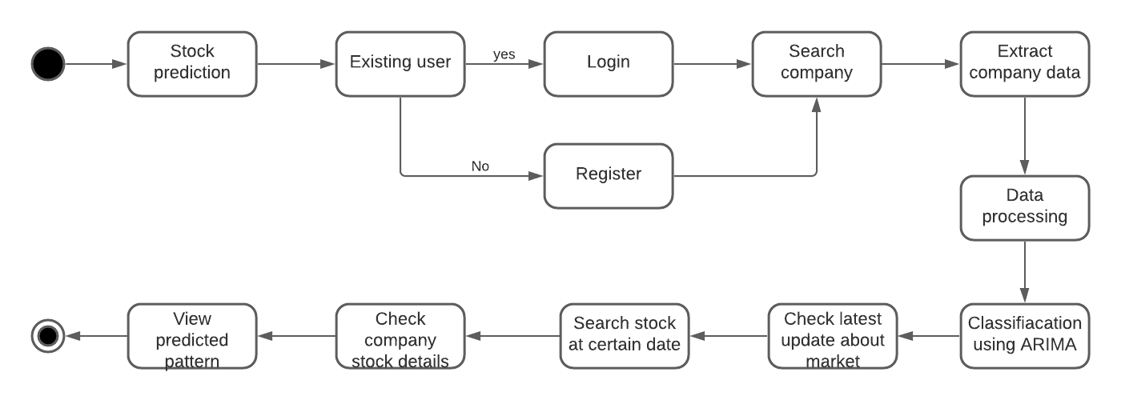

**Conclusion :** Thus, we have prepared uml state diagram using advanced uml2 notations and lucid chart.